# Study of Japanese Immigration in Southern California

## Introduction

Southern California is unique for its high immigrant population, and many from different ethnic backgrounds has made it as a second home town. In particular for a Japanese community, Little Tokyo in downtown Los Angeles had the largest Japanese-American population in the beginning of the 20th century. In 1982, Toyota set its center of operation at Torrance, which is about 20 miles south of Little Tokyo, and many Japanese companies also started to move into Torrance area. Of course, the Japanese community followed the move and formed a new and larger community around the area. But it has been about 40 years since the movement and now the community seems to have expanded their living into wider Southern California. Increased number of Japanese markets and Japanese food restaurants have made it easier for the community to live in different places. Japanese immigrants now have more options to choose from, and a dataset to narrow down the choice may be useful. Here in this study, data from Foursquare API was used to find cities with similar living environment compared to Torrance. Using percentage availability of Japanese restaurant as a representative value for Japanese core culture, the list was then further narrowed down into Top 15 cities to choose from.

## Sample Area

Study area was limited to cities in Los Angeles county and Orange county for the simplicity. The location information was imported from: <https://simplemaps.com/data/us-cities>. Figure 1 shows the map location of each cities including 129 cities from Los Angeles county and 40 cities from Orange county.

*Figure 1. Map*

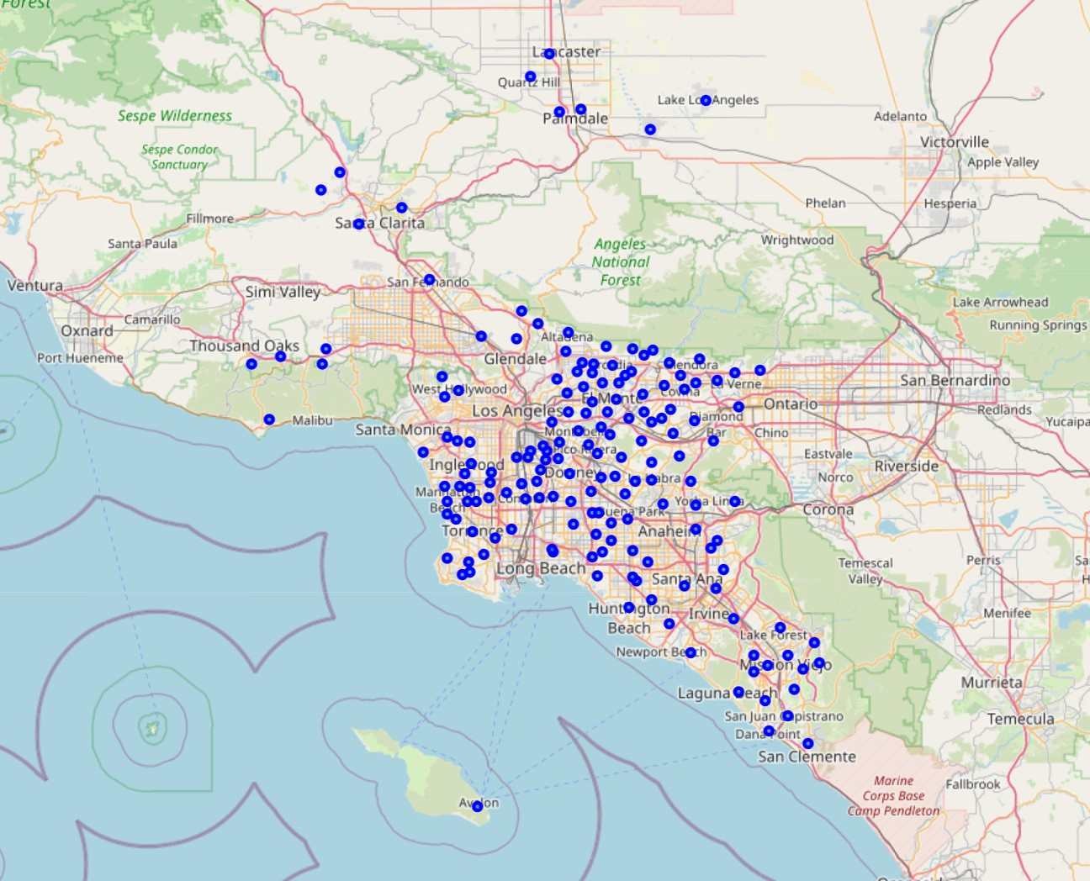

## Analysis

### Foursquare API

Using the location information from above, two types of data was obtained from Foursquare. One is Explore function to get all neighborhood information including restaurants, hotels, parks, museums and etc., and the second is Search function to do a specific search of the neighbor (in this case the search was done for ‘Japanese Restaurant’). The first Explore function was used for all 169 cities to create set numbers of clusters according to the similarities in the neighborhood information. Once the similarity group has been chosen, the cluster which includes the city of Torrance was taken for further study. The Search function was then used for the cluster of cities similar to Torrance to find number of Japanese restaurants nearby.

### Clustering Method

Clustering is a method to group data based on its similarity, and it does not require primary classification knowledge for how to organize data. Technique called K-mean clustering was used, where only variable is to set how many clusters the data will be separated into.

### Clustering the 169 Cities

In order to input the neighborhood explore information into the clustering algorism, the explore data was organized by the rate of venues. Table 1 is an example for Torrance where it shows the top 15 venue categories. The most common venue in Torrance is closing stores and the second most common venue is bakery. List of top 15 venues were created for all 169 cities and the K-mean clustering algorism was used to separate them into different similarity groups. Number (k) of cluster to separate was set to 8, so the 169 cities was separated into 8 groups.

*Table 1. Torrance Top 15*

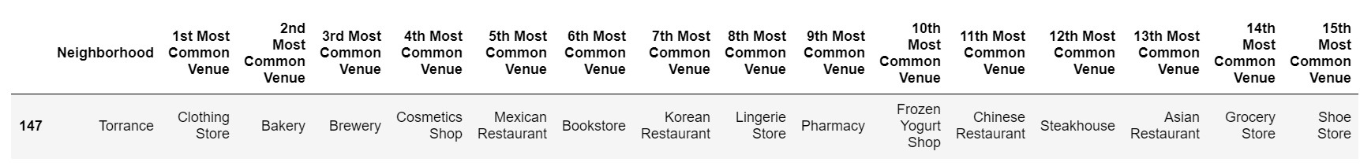

Table 2 and Figure 2 shows the result from the clustering method. Out of the 8 groups, 3 groups contained only one city, are those are outliers or unique cities that didn’t fit to other 5 group’s similarity criteria. Other 5 groups are: cluster 0 with red dots, cluster 1 with purple dots, cluster 3 with light blue dots, cluster 5 with green dots, and cluster 7 with orange dots. It is sometimes difficult to find the similarity criteria just by looking at the lists, but for example cluster 0 with red dots (table 2-a) may be classified as area with more Mexican food and fast-food restaurants. Cluster 5 with green dots (table 2-d) seems to have more Chinese food, Vietnamese food or Asian food. Cluster 7 with orange dots (table 2-e) may be classified as scenic area since they have more trails and parks and scenic lookout spots. Cluster 1 with purple dots and cluster 3 with light blue dots seems to have more complicated criteria.

*Table 2-a*.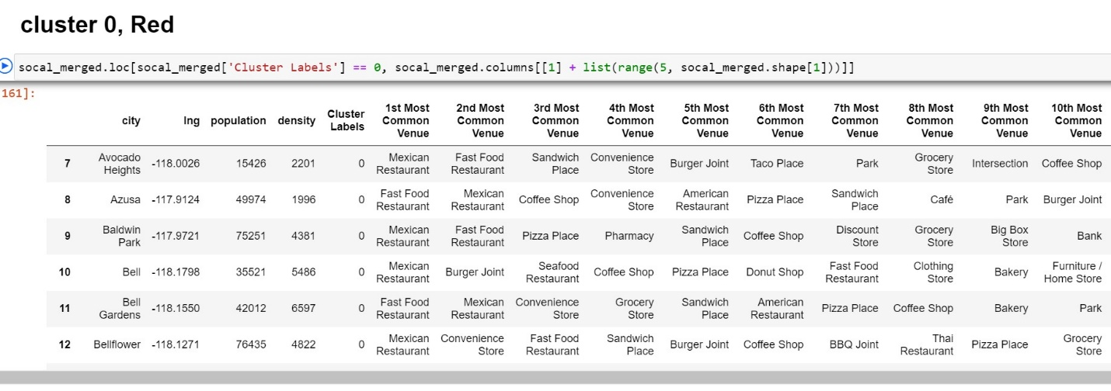

*Table 2-b.*

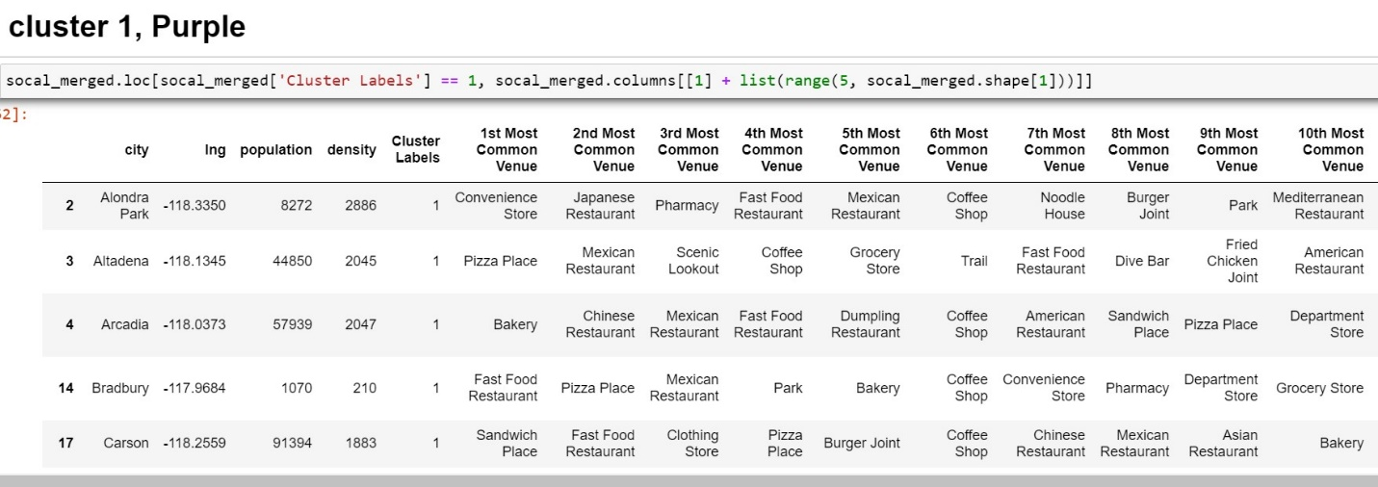

*Table 2-c.*

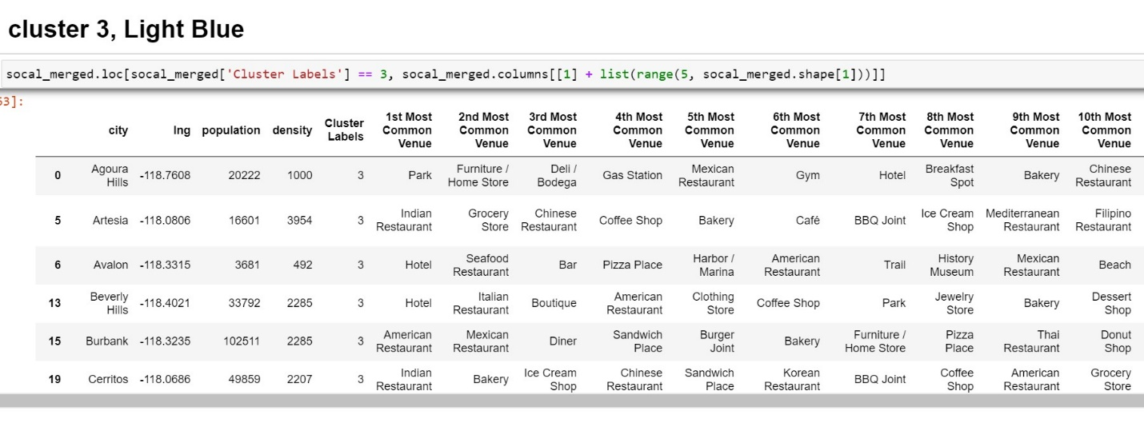

*Table 2-d.*

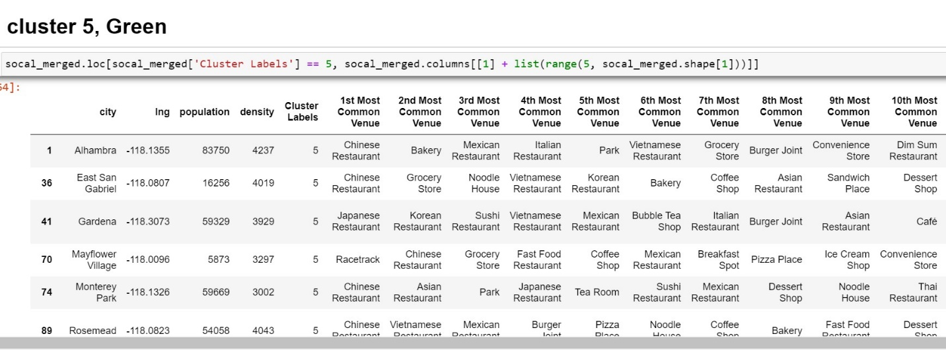

*Table 2-e.*

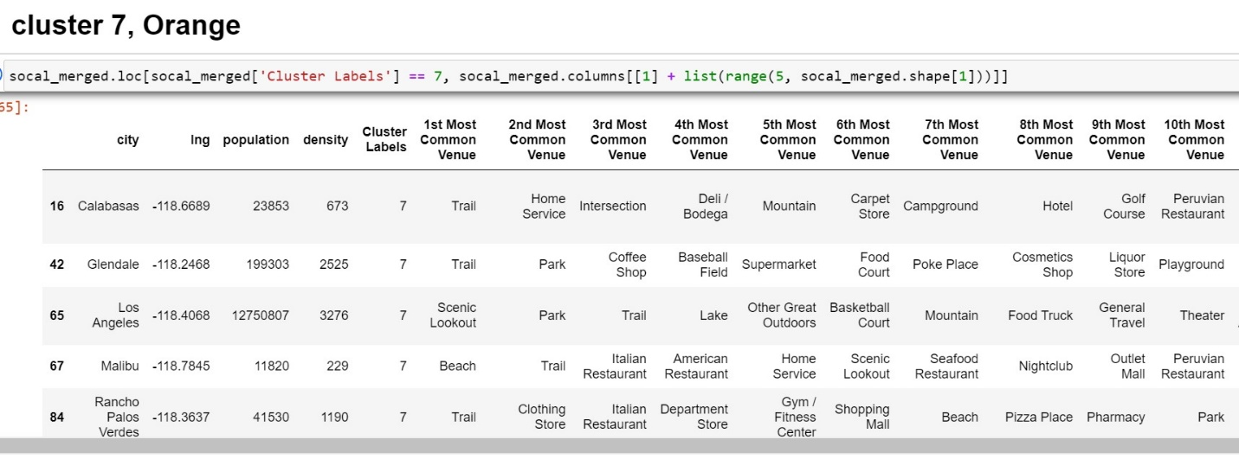

|  |  |
| --- | --- |
| *Figure 2-a. Map View of Cluster Result* | *Figure 2-b. Zoom-in for Los Angeles* |
|  |  |
| *Figure 2-c. Zoom-in for Orange County* |
|  |

Torrance was included in cluster 3 (light blue dots), and this will be the cluster to further look into. According to Little Tokyo Service Center ([www.LTSC.org](http://www.LTSC.org)), Lomita, Redondo Beach, Manhattan Beach, Hermosa Beach, Palos Verdes Peninsula, and Gardena are other highly populated cities with Japanese-American community, and 4 out of those 6 cities also got included in the same cluster as Torrance.

### Comparing the Number of Japanese Restaurants

As figure 2-a shows, cluster 3 includes big portion of cities in Los Angeles and Orange county. In order to further narrow down the choice, Search function from Foursquare API was used to find number of Japanese restaurants in each city. Since the API account used in the study could not be used to find all the Japanese restaurants in the cities, we used a relative ratio of Japanese restaurants to other restaurants for the measure. Table 3 shows the result of top 15 cities of high Japanese restaurant ratio from cluster 3. Lomita and Sierra Madre had the largest percentage of Japanese restaurant ratio from the cities with similar environment compare to Torrance. The list from the top 15 cities also fives wide range of cities from Los Angeles and Orange county, and this may be a good place to start research for those who are considering moving into Southern California from Japan.

*Table 3. Top 15 Cities*

